LETTERKENNY INSTITUTE OF TECHNOLOGY

ASSIGNMENT COVER SHEET

Lecturer’s Name: Ruth Lennon

Assessment Title: OOPR CA2

Work to be submitted to: Turnitin

Date for submission of work: 14/02/2022

Place and time for submitting work: Blackboard via TurnItIn by

To be completed by the Student

Student’s Name: Mukhtar Mohamed Essa

Student Number: L00170168

Class: BDCM OOPR

SubjectModule: OOPR

Word Count (where applicable):

I confirm that the work submitted has been produced solely through my own efforts.

Student’s signature: Mukhtar Date: 14/02/22

|  |
| --- |
| **Notes**  **Penalties:** The total marks available for an assessment is reduced by 15% for work submitted up to one week late. The total marks available are reduced by 30% for work up to two weeks late. Assessment work received more than two weeks late will receive a mark of zero. [Incidents of alleged plagiarism and cheating are dealt with in accordance with the Institute’s Assessment Regulations.]  **Plagiarism:** Presenting the ideas etc. of someone else without proper acknowledgement (see section L1 paragraph 8).  **Cheating:** The use of unauthorised material in a test, exam etc., unauthorised access to test matter, unauthorised collusion, dishonest behaviour in respect of assessments, and deliberate plagiarism (see section L1 paragraph 8).  **Continuous Assessment:** For students repeating an examination, marks awarded for continuous assessment, shall normally be carried forward from the original examination to the repeat examination. |

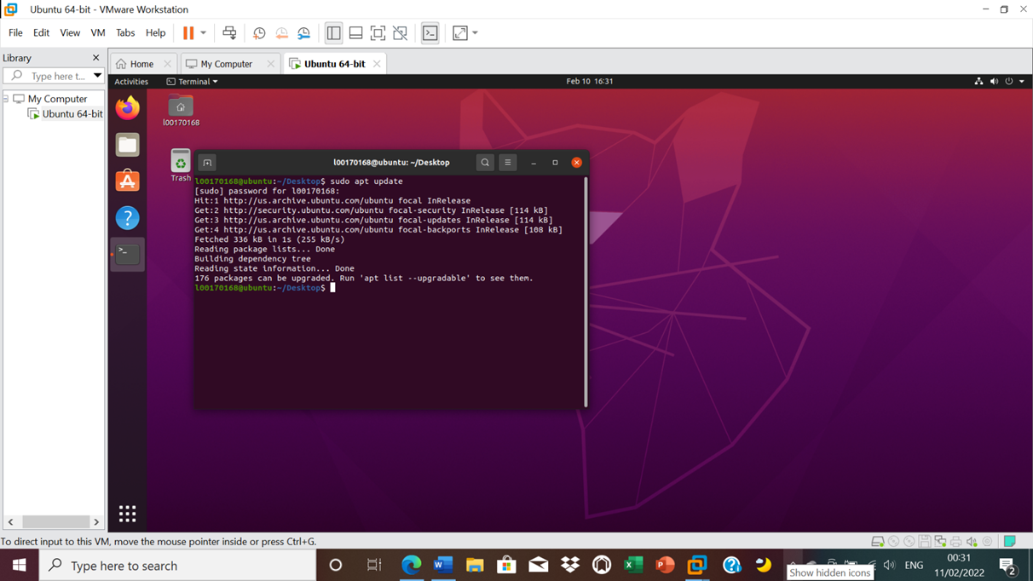

1 Figure 1 Intstalling apache2 on ubuntuVmware

Figure 1 Server is running as you can see in the screenshot

Figure 2 apache page is working

Figure 3 the apache2 webpage I have created

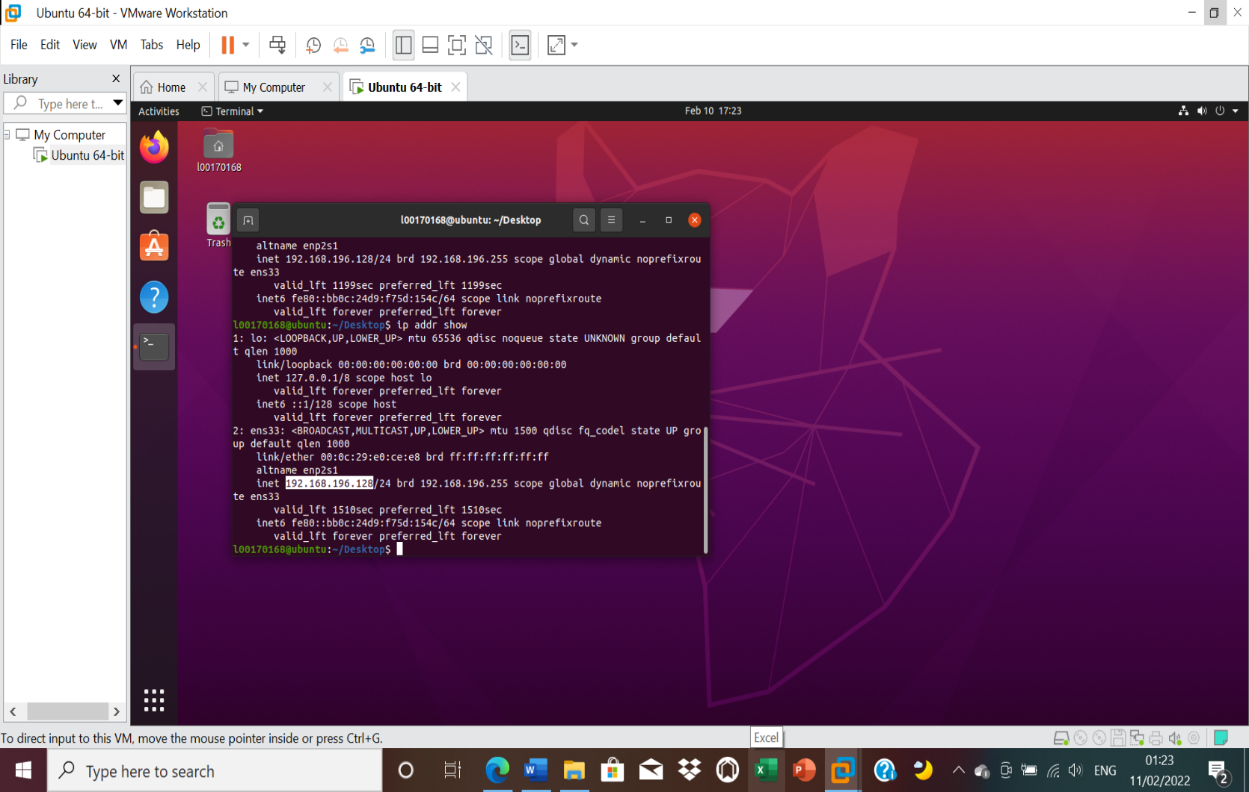

Figure 4 ip addr is 192.168.196.128 and matches with apache page